Title : Create a SDN environment on mininet and configure a switch to provide a firewall
functionality using pox controller.
Name : - Mehatab Mahibub Sanadi
Roll No. : - CO4050
Class : - BE Computer
Subject : - Software Defined Networks
*********************************************************************
Step 1: Install Mininet & POX
Install Mininet:
sudo apt update
sudo apt install mininet -y
Install POX:
cd ~
git clone https://github.com/noxrepo/pox.git
cd pox

Step 2: Create Simple Topology (Remote Controller)
Open new terminal:
sudo mn --topo single,3 --mac --switch ovsk --controller remote

his creates:
1 switch (s1)
3 hosts (h1, h2, h3)
Remote controller connection

Step 3: Create Firewall Program in POX
Go to POX directory:
cd ~/pox
Create file:
nano firewall.py
Paste this Code:-
from pox.core import core
import pox.openflow.libopenflow_01 as of

log = core.getLogger()

class Firewall(object):

def __init__(self):
core.openflow.addListeners(self)
log.info("Firewall initialized")

def _handle_ConnectionUp(self, event):
msg = of.ofp_flow_mod()
msg.priority = 65535

msg.match.dl_type = 0x0800
msg.match.nw_proto = 6
msg.match.tp_dst = 80

# NO ACTION → DROP PACKETS
event.connection.send(msg)

def launch():
core.registerNew(Firewall)
Save:
Press CTRL + X
Press Y
Press Enter

Step 4: Run POX Controller with Firewall
sudo python3 pox.py log.level --DEBUG openflow.discovery openflow.spanning_tree forwarding.l2_learning firewall
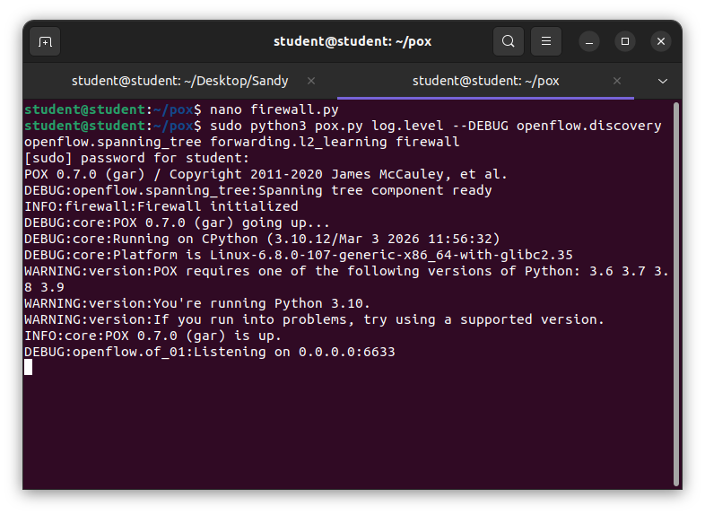
This:
- Runs POX
- Enables learning switch
- Activates firewall

Step 5: Test Firewall in Mininet
Go to Mininet terminal:

Test Normal Ping (Should Work)
h1 ping h2
✔ Output: SUCCESS
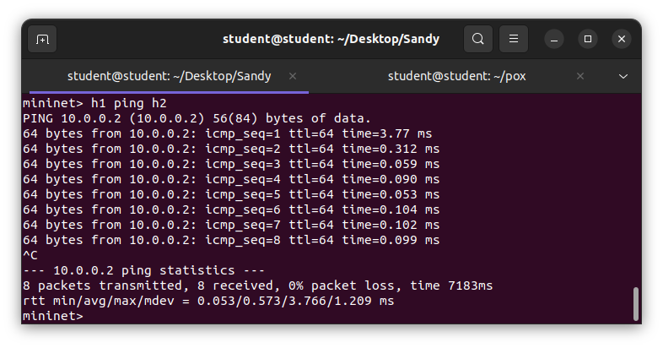
Test HTTP Traffic (Should Block)
h1 wget h2
✔ Expected:
Request FAILS ❌
Because port 80 is blocked
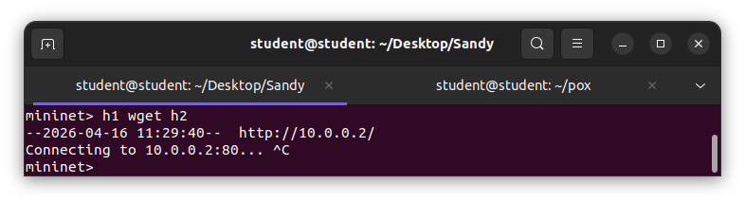
Step 6: Observe Behavior
What happens:
- Switch sends packet to controller
- Controller applies firewall rule
- Traffic on port 80 is blocked
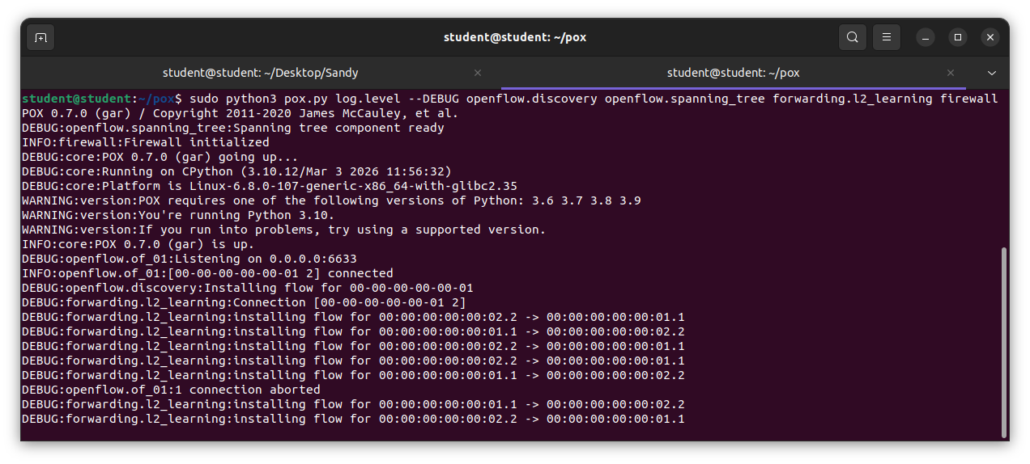
Step 7: View Flow Entries
dpctl dump-flows
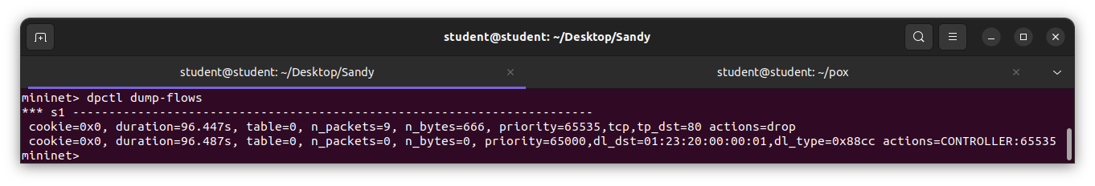
You will see:
High priority rule
Matching TCP port 80

Step 8: Exit & Clean
exit
sudo mn -c

Conclusion : We learn how to install Mininet and how to created an SDN environment on Mininet andconfigured a switch to provide firewall functionality using POX controller.

